Statistical Learning Lab
Assignment - 4
Cross-validation and Bootstrapping
Anurag Singha | 22IM30007
Show the code snippets and the corresponding output for the following:
Q1)Load the dataset “manufacturing.csv”. Display first few rows of the dataset. Take “Quality Rating” as response variable.

Ans:-
Code:-
setwd('C:/Users/USER/OneDrive - iitkgp.ac.in/Desktop/Stat Lab/Validation and Bootstrating')
data <- read.csv("manufacturing.csv")
head(data)
target_variable <- data$Quality.Rating

Output:-

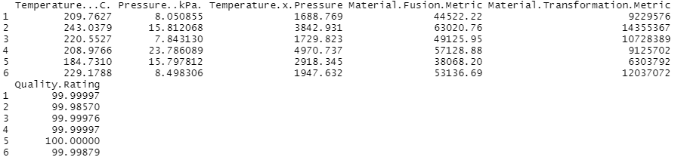

Q2)Fit polynomial models between Quality ~ Temp. Vary the degree of polynomial on temperature from 1 to 5 (temp, temp^2, temp^3 etc.). Perform LOOCV, k-fold CV for k=5 and 10 and compare the cross-validation MSE errors for different degrees of polynomials. Create a table showing the CV errors for different degree of polynomials and for different CV techniques. Plot the results. Discuss which degree of polynomial is preferable.
Ans:-
Code:-
library(boot)
colnames(data)
poly_degrees <- 1:5
cv_results <- data.frame(Degree = poly_degrees, LOOCV_Error = NA, K5_Error = NA, K10_Error = NA)

kfold_cross_validation <- function(model_formula, dataset, num_folds) {
total_rows <- nrow(dataset)
split_size <- floor(total_rows / num_folds)
mse_accumulator <- 0

for (fold in 1:num_folds) {
test_idx <- ((fold - 1) * split_size + 1):(fold * split_size)
test_data <- dataset[test_idx, ]
train_data <- dataset[-test_idx, ]

fitted_model <- lm(model_formula, data = train_data)
predicted_vals <- predict(fitted_model, newdata = test_data)
actual_vals <- test_data$Quality.Rating
mse_accumulator <- mse_accumulator + mean((predicted_vals - actual_vals)^2)
}
return(mse_accumulator / num_folds)
}

for (deg in poly_degrees) {
poly_features <- paste("I(`Temperature...C.`^", 1:deg, ")", collapse = " + ")
model_formula <- as.formula(paste("Quality.Rating ~", poly_features))

print(paste("Training model for Degree", deg, ":", model_formula))

loocv_eval <- cv.glm(data, glm(model_formula, data = data), K = nrow(data))
print(paste("LOOCV Error for Degree", deg, ":", loocv_eval$delta[1]))
cv_results$LOOCV_Error[cv_results$Degree == deg] <- loocv_eval$delta[1]

k5_eval <- kfold_cross_validation(model_formula, data, 5)
k10_eval <- kfold_cross_validation(model_formula, data, 10)

print(paste("5-Fold CV Error for Degree", deg, ":", k5_eval))
print(paste("10-Fold CV Error for Degree", deg, ":", k10_eval))

cv_results$K5_Error[cv_results$Degree == deg] <- k5_eval
cv_results$K10_Error[cv_results$Degree == deg] <- k10_eval
}
print(cv_results)

library(ggplot2)
cv_results_long <- reshape(cv_results,
varying = c("LOOCV_Error", "K5_Error", "K10_Error"),
v.names = "MSE",
timevar = "CV_Method",
times = c("LOOCV", "K5CV", "K10CV"),
direction = "long")

ggplot(cv_results_long, aes(x = Degree, y = MSE, color = CV_Method)) +
geom_line() +
geom_point() +
theme_minimal() +
labs(title = "Cross-Validation MSE for Polynomial Degrees",
x = "Polynomial Degree", y = "Mean Squared Error") +
theme(legend.title = element_blank())

Output:-

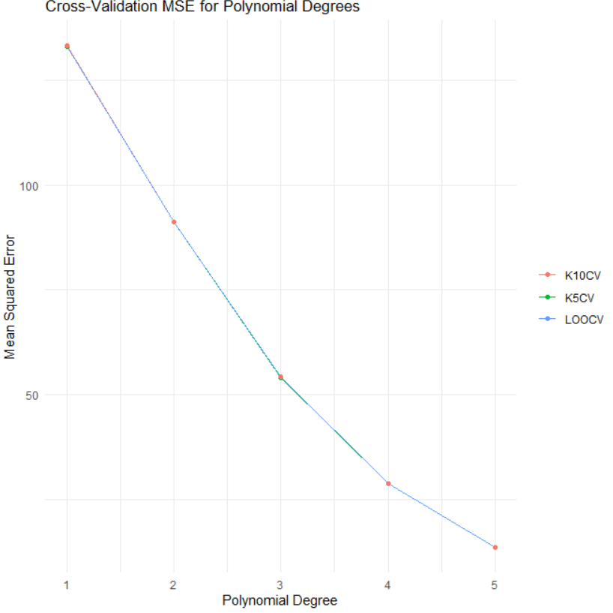
Conclusion:Degrre 5 is Preferable as it has least MSE among them

3.Perform the analysis in problem no. 2, but this time, fit linear models with different combination of X variables, without interaction. Discuss which model is most preferable based on the cross-validation results. Plot the results and on X-axis labels, provide the X-variable combinations used in the model, e.g. (temp, temp-press, temp-matfus, temp-matfus-mattr etc.)
Ans:-
Code:-
feature_combinations <- list(
c("Temperature...C."),
c("Temperature...C.", "Pressure..kPa."),
c("Temperature...C.", "Material.Fusion.Metric"),
c("Temperature...C.", "Material.Transformation.Metric"),
c("Temperature...C.", "Pressure..kPa.", "Material.Fusion.Metric"),
c("Temperature...C.", "Pressure..kPa.", "Material.Transformation.Metric"),
c("Temperature...C.", "Material.Fusion.Metric", "Material.Transformation.Metric"),
c("Temperature...C.", "Pressure..kPa.", "Material.Fusion.Metric", "Material.Transformation.Metric")
)

cv_summary_results <- data.frame(Combination = character(0), LOOCV_Error = numeric(0), K5_Error = numeric(0), K10_Error = numeric(0))

for (features in feature_combinations) {
model_expression <- paste("Quality.Rating ~", paste(features, collapse = " + "))
model_formula <- as.formula(model_expression)

print(paste("Evaluating model with variables:", model_expression))

loocv_res <- cv.glm(data, glm(model_formula, data = data), K = nrow(data))
loocv_mse <- loocv_res$delta[1]

k5_mse <- kfold_cross_validation(model_formula, data, 5)
k10_mse <- kfold_cross_validation(model_formula, data, 10)

cv_summary_results <- rbind(cv_summary_results, data.frame(Combination = model_expression, LOOCV_Error = loocv_mse, K5_Error = k5_mse, K10_Error = k10_mse))
}

print(cv_summary_results)

library(reshape2)

cv_results_long <- reshape(cv_summary_results,
varying = c("LOOCV_Error", "K5_Error", "K10_Error"),
v.names = "MSE",
timevar = "CV_Method",
times = c("LOOCV", "K5CV", "K10CV"),
direction = "long")

ggplot(cv_results_long, aes(x = Combination, y = MSE, color = CV_Method, group = CV_Method)) +
geom_point() +
geom_line() +
theme_minimal() +
labs(title = "Cross-Validation MSE for Different Predictor Combinations",
x = "Predictor Combinations", y = "Mean Squared Error") +
theme(axis.text.x = element_text(angle = 45, hjust = 1), legend.title = element_blank())
Output:-

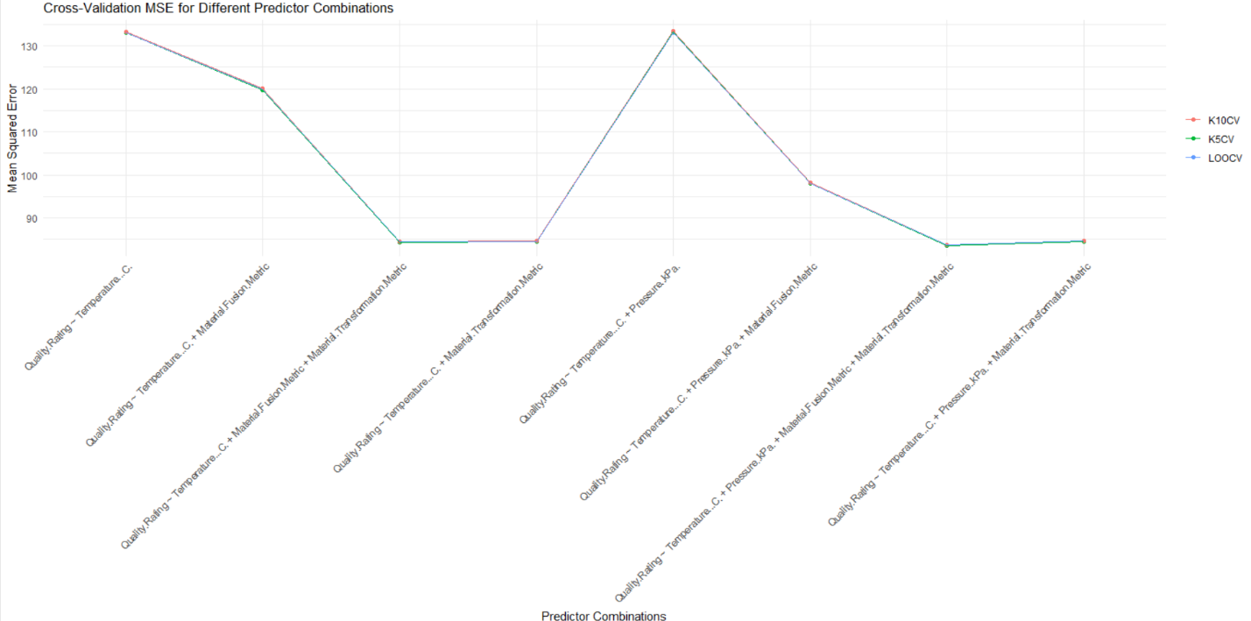

4)Generate 50 random numbers from Normal Distribution $N(μ=50, σ^{2}=2)$. Now create 100 bootstrap samples with 20 datapoints each, with replacement. Estimate the mean and variance of the population from the bootstrap samples.
Ans:-
Code:-
set.seed(123)

random_population <- rnorm(50, mean = 50, sd = sqrt(2))

bootstrap_means <- numeric(100)
bootstrap_variances <- numeric(100)

for (iteration in 1:100) {
sample_subset <- sample(random_population, size = 20, replace = TRUE)

bootstrap_means[iteration] <- mean(sample_subset)
bootstrap_variances[iteration] <- var(sample_subset)
}

estimated_mean <- mean(bootstrap_means)
estimated_variance <- mean(bootstrap_variances)
estimated_mean
estimated_variance
Output:
> estimated_mean
[1]50.05668
> estimated_variance
[1] 1.733931
Conclusion:
Estimated Population Mean from Bootstrap Samples: 50.05668
Estimated Population Variance from Bootstrap Samples: 1.733931

Statistical Learning Lab
Assignment - 3
LDA-QDA-KNN
Anurag Singha | 22IM30007
Show the code snippets and the corresponding output for the following:
- Load the dataset “diabetes.csv”. Display the first few rows of the dataset. A1. Loaded the data set using the read.csv command.
#Code
data <- read.csv("diabetes.csv")
head(data)

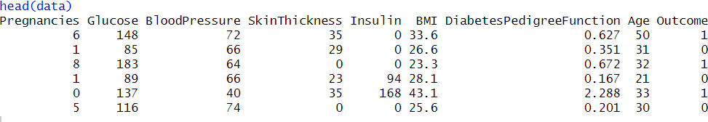

- Perform preliminary analysis to show how the variables are related. Use scatter plots, box plots, etc., to visualise how different variables impact the “Outcome” variable.
Checking for missing values:
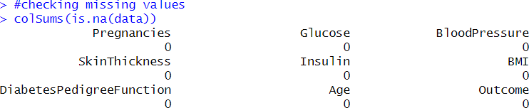

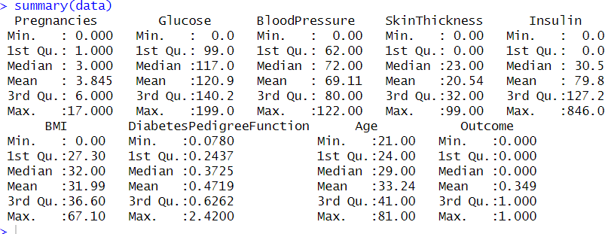
Used pairs(data, main = "Scatter Plot Matrix") to plot scatter Plot.
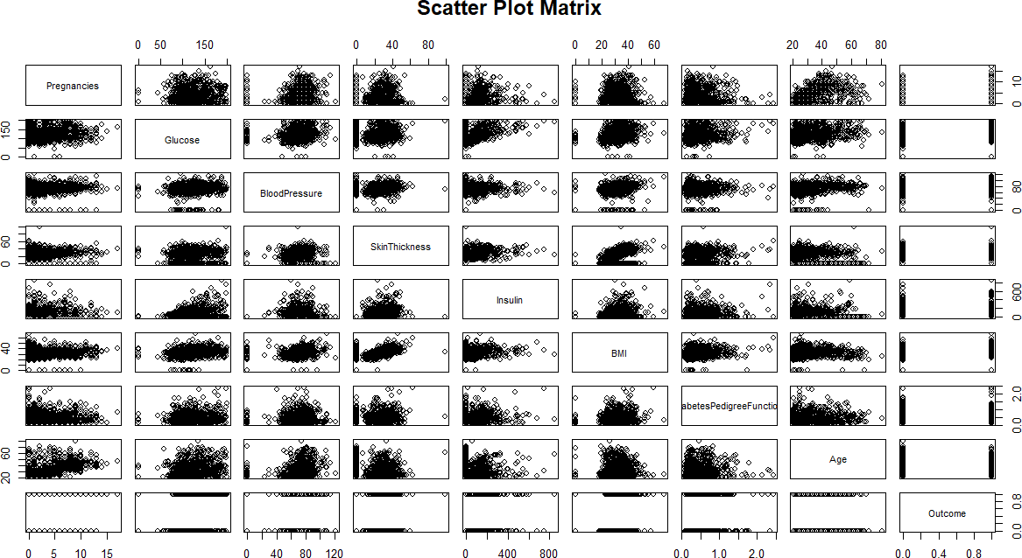

Code:
par(mfrow = c(1, 2))
for (col in colnames(data)[-ncol(data)]) { boxplot(data[[col]] ~ data$Outcome,
main = paste(col, "vs Outcome"), xlab = "Outcome",
ylab = col,
col = c("lightblue", "pink"))
}

Box Plots:
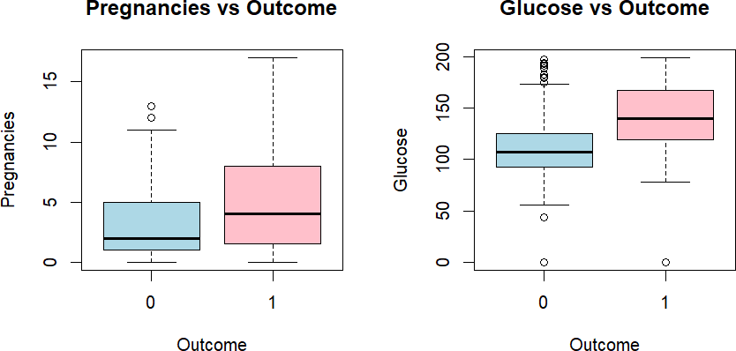
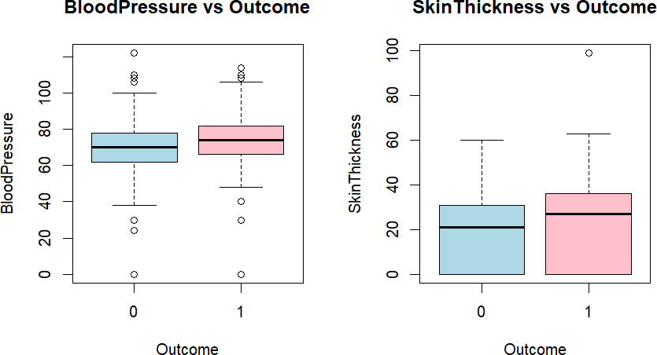

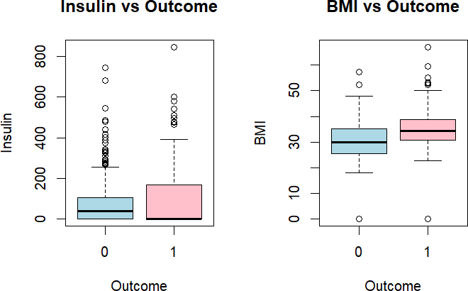
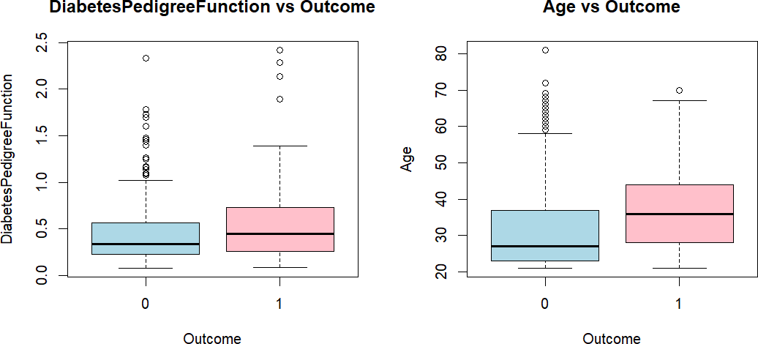

Syntax for correlation plot:
cor_matrix <- cor(data) print(cor_matrix) library(corrplot) mfrow(1,1)
corrplot(cor_matrix,method="color" ,type = "upper", tl.col = "black", tl.cex=0.8)

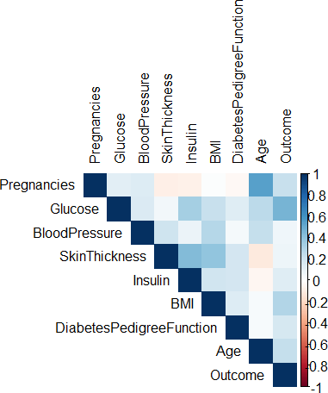

Outcome Correlations:

- Strong with Glucose (~0.46).
- Moderate with BMI (~0.29) and Pregnancies (~0.22).
- Weak with DiabetesPedigreeFunction (~0.17) and Age (~0.20).

Predictor Relationships:

- Strong: SkinThickness vs. BMI (~0.39).
- Moderate: Glucose vs. BMI (~0.22), Insulin vs. Glucose (~0.33), and Age vs.
Pregnancies (~0.54).

Q3) Randomly sample 80% of the data as training data and rest
as test data. Fit a LDA model and interpret the result.
Code:

Outcome:
Inferences:
- Glucose is a dominant predictor of diabetes, as it is much higher in diabetics.
- Genetics (Diabetes Pedigree Function) has a strong impact on predicting diabetes.
- Obesity (BMI) and Insulin levels also influence diabetes classification.
- Pregnancy history, age, and blood pressure contribute, but with less influence.
Q4) From the model fitted in problem 3, derive confusion
matrix, accuracy, and F1-score on test data.
Code:
Confusion Matrix:
Code:
Calculating accuracy
Code:
Result:
Q5) Fit QDA and KNN (K = 5) models on training data. Compare
the metrics in problem 4 for LDA, QDA and KNN models for
test data and discuss the results.
Code::

Inference & Comparison of Model Performance

Accuracy:
- LDA achieves the highest accuracy at 0.7792, making it the most effective model in terms of overall correct predictions on the test data.
- QDA follows closely with an accuracy of 0.7532, slightly lower than LDA.
- KNN has the lowest accuracy at 0.7338, suggesting that it may struggle in this scenario, potentially due to sensitivity to feature scaling or the choice of K.

F1 Score:
- LDA also outperforms the other models in terms of F1 score (0.6304), indicating a strong balance between precision and recall for the positive class.
- KNN follows with an F1 score of 0.5859, slightly higher than QDA (0.5778). This suggests that while KNN has the lowest accuracy, it maintains a better balance of precision and recall compared to QDA.
- QDA has the lowest F1 score, implying that while it correctly classifies a reasonable number of samples (as reflected in accuracy), it may struggle in balancing precision and recall effectively.

Conclusion:
- LDA emerges as the most effective model, achieving the highest accuracy and F1 score, making it a strong candidate for this problem.
- KNN, despite having the lowest accuracy, maintains a relatively balanced F1 score, indicating that it still captures some relevant patterns.
- QDA ranks lowest in terms of F1 score, suggesting it may not be as effective in distinguishing between positive and negative classes, even though its accuracy remains fairly competitive.
Overall, LDA appears to be the most reliable model, followed by KNN, with QDA performing the weakest based on these evaluation metrics.

Q6) Plot ROC curve for LDA and QDA models using the test
data.
->Code:
Plots:
Q7) Plot accuracy and f1-score by varying the neighbourhood
size from K=1 to K=20 and interpret the results.
Code:
Output:
Interpretation:
Accuracy and F1-Score Behavior:
At K=1, the accuracy is significantly high (around 0.7).
As K increases, accuracy drops sharply and remains close to zero for all larger K values.
The F1-score remains near zero for all K values, indicating poor classification performance.

Statistical Learning Lab
Assignment - 2
Logistic Regression Assignment
Anurag Singha | 22IM30007
Show the code snippets and the corresponding output for the following:
- Load the dataset “diabetes.csv”. Display the first few rows of the dataset. A1. Loaded the data set using the read.csv command.

- Perform preliminary analysis to show how the variables are related. Use scatter plots, box plots, etc., to visualise how different variables impact the “Outcome” variable.
A2.
Checking for missing values:

Used pairs(data, main = "Scatter Plot Matrix") to plot scatter Plot.

Syntax for Box plot:
par(mfrow = c(1, 2))
for (col in colnames(data)[-ncol(data)]) { boxplot(data[[col]] ~ data$Outcome,
main = paste(col, "vs Outcome"), xlab = "Outcome",
ylab = col,
col = c("lightblue", "pink"))
}

Box Plots:

Syntax for correlation plot:
cor_matrix <- cor(data) print(cor_matrix) library(corrplot) mfrow(1,1)
corrplot(cor_matrix,method="color" ,type = "upper", tl.col = "black", tl.cex=0.8)

Outcome Correlations:

- Strong with Glucose (~0.46).
- Moderate with BMI (~0.29) and Pregnancies (~0.22).
- Weak with DiabetesPedigreeFunction (~0.17) and Age (~0.20).

Predictor Relationships:

- Strong: SkinThickness vs. BMI (~0.39).
- Moderate: Glucose vs. BMI (~0.22), Insulin vs. Glucose (~0.33), and Age vs.
Pregnancies (~0.54).

- Randomly sample 80% of the data as training data and the rest as test data. Fit a Logistic Regression model with all the predictors on training data. From the summary, which factors are significant? Explain how the predictors impact the log-odds ratio of diagnosed with diabetes (Outcome)
A3. Syntax:
# Split data into training and testing sets (80%-20%) train_index <- sample(1:nrow(data), 0.8 * nrow(data)) train_data <- data[train_index, ]
test_data <- data[-train_index, ]

# Logistic Regression Model (M1)
M1 <- glm(Outcome ~ ., data = train_data, family = binomial) summary(M1)

Output Summary:
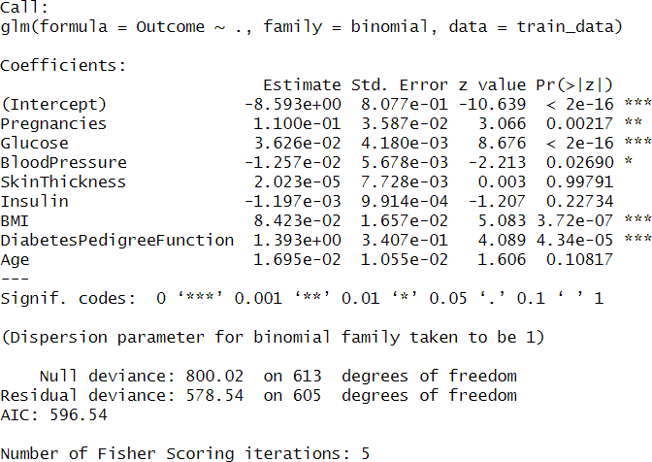

Significant Factors in the Logistic Regression Model

Based on the p-values (Pr(>|z|) < 0.05), the significant predictors impacting diabetes diagnosis are:
- Glucose (p < 2e-16*)**
- BMI (p = 3.72e-07*)**
- Diabetes Pedigree Function (p = 4.34e-05*)**
- Pregnancies (p = 0.00217)**
- Blood Pressure (p = 0.02690*)

Impact on Log-Odds Ratio (Risk of Diabetes)

- Glucose (+0.0363): A 1-unit increase in glucose raises the log-odds of diabetes by
0.0363, making it the most influential predictor.
- BMI (+0.0842): A higher BMI increases the log-odds of diabetes, meaning obesity is a key risk factor.
- Diabetes Pedigree Function (+1.393): A strong genetic component; higher values significantly increase diabetes risk.
- Pregnancies (+0.110): More pregnancies slightly raise the likelihood of diabetes.
- Blood Pressure (-0.0125): A slight negative effect, though weakly significant.

Non-Significant Factors (p > 0.05)

- SkinThickness, Insulin, Age show no firm evidence of impact.

- From the model fitted in problem 3, derive the confusion matrix, accuracy, and F1-score on test data.
A4.
Syntax:
# Predictions on test data
test_predictions <- ifelse(predict(M1, newdata = test_data, type = "response") > 0.5, 1, 0)

# Confusion Matrix
confusion_matrix <- table(test_data$Outcome, test_predictions,
dnn = c("Actual", "Predicted"))
confusion_matrix

# Accuracy
accuracy <- sum(diag(confusion_matrix)) / sum(confusion_matrix)

# F1-Score
precision <- confusion_matrix[2, 2] / sum(confusion_matrix[2, ]) recall <- confusion_matrix[2, 2] / sum(confusion_matrix[, 2]) F1_score <- 2 * (precision * recall) / (precision + recall)

list(Accuracy = accuracy, F1_Score = F1_score)

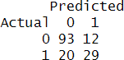
Output:

fig: Confusion Matrix

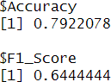
fig: Accuracy and F1 score

- Let’s call the model fitted in problem 3 M1. Now choose predictors “Pregnancies”, “Glucose”, and “BMI” and fit a model (M2). Compare these two models' deviances and perform hypothesis tests to show whether M1 is significantly more informative than M2.
A5.
Syntax:
# Logistic Regression Model (M2)
M2 <- glm(Outcome ~ Pregnancies + Glucose + BMI, data = train_data, family = binomial)

deviance_diff <- deviance(M2) - deviance(M1)
# Chi-squared critical value for alpha = 0.05 and df = difference in parameters
dof <- length(coef(m1)) - length(coef(m2)) critical_value <- qchisq(0.95, df = dof)

# Output results
cat("Deviance Difference:", deviance_diff, "\n") cat("Chi-Square Critical Value:", critical_value, "\n") Output:
Deviance Difference: 25.65425
Chi-Square Critical Value: 11.0705
Since the value of the Deviance difference is greater than the critical value, M1 is significantly more informative than M2.

Entire Code:
# Load the data set data <-
read.csv("diabetes.csv", header = TRUE)

# Display the first few rows head(data)

#checking missing values colSums(is.na(data))

summary(data)

# Scatter plot matrix
pairs(data, main = "Scatter Plot Matrix")

# Box plots for categorical Outcome variable against predictors par(mfrow = c(1, 2))
for (col in colnames(data)[-ncol(data)]) { boxplot(data[[col]] ~ data$Outcome,
main = paste(col, "vs Outcome"), xlab = "Outcome",
ylab = col,
col = c("lightblue", "pink"))
}

num_data <- data[,sapply(data,is.numeric)] #select only numeric data no categoric data
cor_matrix <- cor(num_data,use ="complete.obs") print(cor_matrix)
library(corrplot) corrplot(cor_matrix,method="circle",addCoef.col = "black")

# Split data into training and testing sets (80%-20%) train_index <- sample(1:nrow(data), 0.8 * nrow(data)) train_data <- data[train_index, ]
test_data <- data[-train_index, ]

# Logistic Regression Model (M1)
M1 <- glm(Outcome ~ ., data = train_data, family = binomial) summary(M1)

# Predictions on test data
test_predictions <- ifelse(predict(M1, newdata = test_data, type = "response") > 0.5, 1, 0)

# Confusion Matrix
confusion_matrix <- table(test_data$Outcome, test_predictions,
dnn = c("Actual", "Predicted"))
confusion_matrix

# Accuracy
accuracy <- sum(diag(confusion_matrix)) / sum(confusion_matrix)

# F1-Score
precision <- confusion_matrix[2, 2] / sum(confusion_matrix[2, ]) recall <- confusion_matrix[2, 2] / sum(confusion_matrix[, 2]) F1_score <- 2 * (precision * recall) / (precision + recall)

list(Accuracy = accuracy, F1_Score = F1_score)

# Logistic Regression Model (M2)
M2 <- glm(Outcome ~ Pregnancies + Glucose + BMI, data = train_data, family = binomial)

deviance_diff <- deviance(M2) - deviance(M1)
# Chi-squared critical value for alpha = 0.05 and df = difference in parameters
dof <- length(coef(M1)) - length(coef(M2)) critical_value <- qchisq(0.95, df = dof)

# Output results
cat("Deviance Difference:", deviance_diff, "\n") cat("Chi-Square Critical Value:", critical_value, "\n")

# Check significance
if (abs(deviance_diff) < critical_value) { cat("Conclusion: M2 is as significant as M1.\n")
} else {
cat("Conclusion: M1 is significantly better than M2.\n")
}

Statistical Learning Lab
Assignment - 5
Subset Selection Regularization and Dimension Reduction
Anurag Singha | 22IM30007

- Load the dataset “Cellphone.csv”. Display the first few rows of the dataset.
Code
cell_phone = read.csv(path)
head(cell_phone)
Output
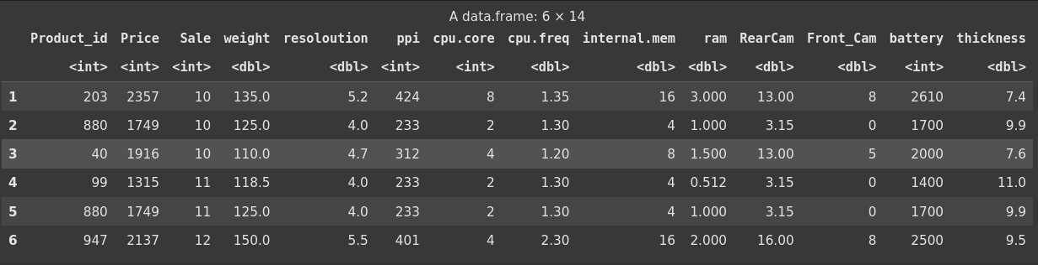
2. Perform preliminary analysis to show how the variables are related to each other. Use scatter plot, box plot etc. to visualize how different variables impact the “Price” variable, which is the response variable.
Code

# Remove Product_id for analysis
data_analysis <- cell_phone[, -1]
# Correlation matrix heatmap
cor_matrix <- cor(data_analysis)
corrplot(cor_matrix, method = "circle", type = "upper", order = "hclust", tl.col = "black", tl.srt = 45)

# Scatter plots for selected variables against Price
par(mfrow = c(2, 2))
plot(data_analysis$weight, data_analysis$Price, xlab = "Weight", ylab = "Price",
main = "Price vs Weight")
plot(data_analysis$ram, data_analysis$Price, xlab = "RAM", ylab = "Price",
main = "Price vs RAM")
plot(data_analysis$battery, data_analysis$Price, xlab = "Battery", ylab = "Price",main = "Price vs Battery")
plot(data_analysis$thickness, data_analysis$Price, xlab = "Thickness", ylab = "Price",main = "Price vs Thickness")

# Box plot for cpu.core vs Price
boxplot(Price ~ cpu.core, data = data_analysis,xlab = "CPU Core", ylab = "Price", main = "Price by CPU Core")

Output
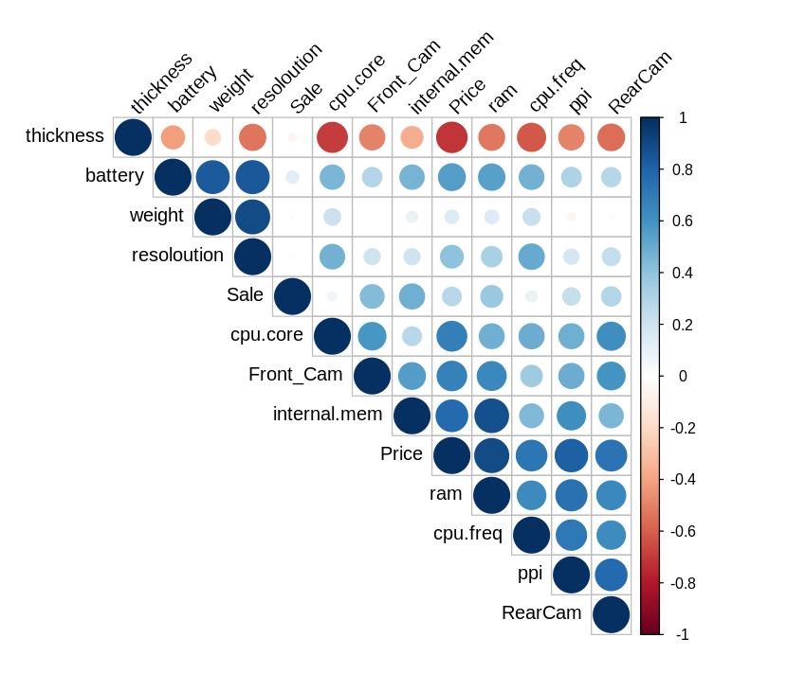
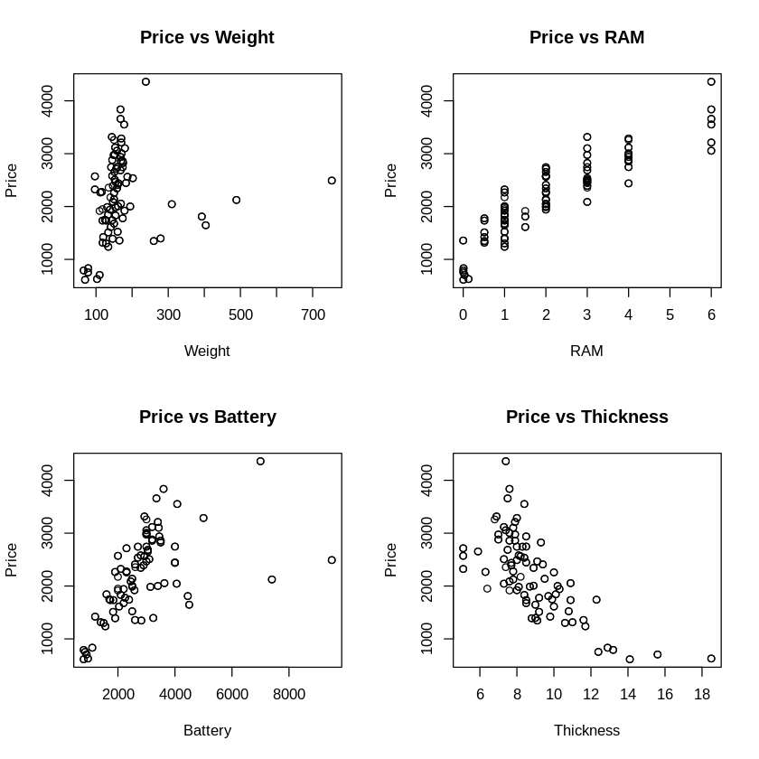
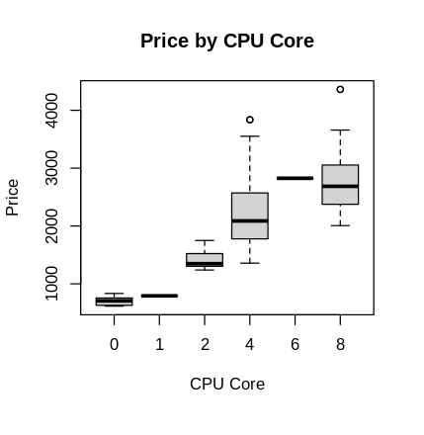
3. Perform the best subset selection on this dataset (dropping the Product_id variable). Explain the results.
Code
# Perform best subset selection, excluding Product_id
subsets <- regsubsets(Price ~ ., data = data_analysis, nvmax = 12)
summary_subsets <- summary(subsets)
# Display the summary
print(summary_subsets)
Output
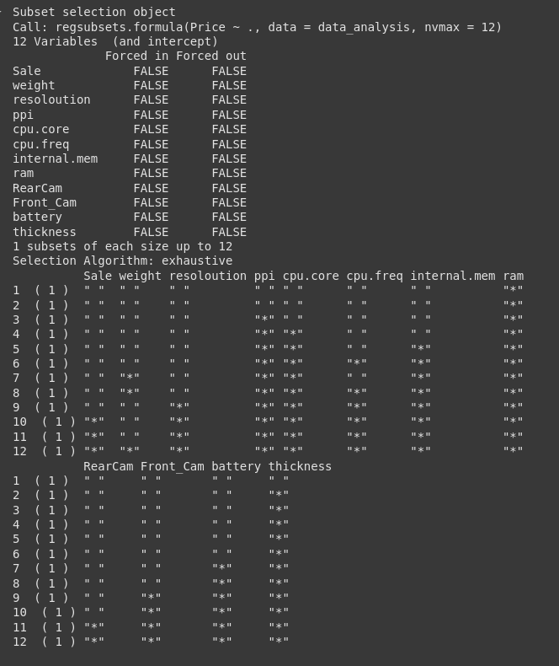

Discussion -
The best subset selection involves an exhaustive search to identify the optimal combination of predictors for Price across models ranging from 1 to 12 variables, minimizing the residual sum of squares (RSS). In the single-variable model, ram emerges as the strongest predictor. The two-variable model adds thickness, highlighting their combined significance. The three-variable model includes ppi, ram, and thickness, while the four-variable model further incorporates cpu.core. As the model size increases, additional variables such as internal.mem, cpu.freq, weight, battery, resolution, Front_Cam, Sale, and RearCam are sequentially included, with all 12 appearing in the largest model. Notably, ram and thickness are consistently selected early, indicating their strong predictive power, whereas Sale and RearCam are included only in larger models, suggesting a lesser or redundant contribution. Selecting the best model would typically involve assessing criteria like Cp, BIC, or adjusted R-squared (not provided here) to balance model fit and complexity.

4. Create a plot with Cp on y-axis and number of variables on the x-axis. Determine the lowest Cp and report how many variables are included in the lowest Cp model.
Code
# Extract Cp values
cp_values <- summary_subsets$cp

# Plot Cp against number of variables
plot(1:12, cp_values, type = "b", xlab = "Number of Variables", ylab = "Cp",
main = "Cp vs Number of Variables")
min_cp_index <- which.min(cp_values)
points(min_cp_index, cp_values[min_cp_index], col = "red", pch = 19)
abline(h = cp_values[min_cp_index], col = "red", lty = 2)

# Report the number of variables in the lowest Cp model
cat("Number of variables in the model with the lowest Cp:", min_cp_index, "\n")

# Variables in the best model
best_model_vars <- names(coef(subsets, id = min_cp_index))[-1] # Exclude intercept
cat("Variables included:", paste(best_model_vars, collapse = ", "), "\n")

# Extract Cp values
cp_values <- summary_subsets$cp

# Plot Cp against number of variables
plot(1:12, cp_values, type = "b", xlab = "Number of Variables", ylab = "Cp",
main = "Cp vs Number of Variables")
min_cp_index <- which.min(cp_values)
points(min_cp_index, cp_values[min_cp_index], col = "red", pch = 19)
abline(h = cp_values[min_cp_index], col = "red", lty = 2)

# Report the number of variables in the lowest Cp model
cat("Number of variables in the model with the lowest Cp:", min_cp_index, "\n")

# Variables in the best model
best_model_vars <- names(coef(subsets, id = min_cp_index))[-1] # Exclude intercept
cat("Variables included:", paste(best_model_vars, collapse = ", "), "\n")
Output
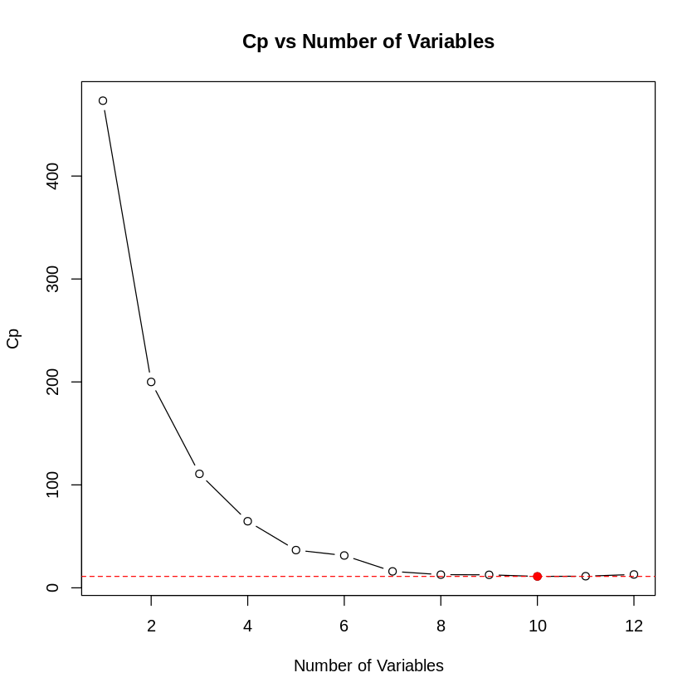
5. Plot the best subset selection output and explain the plot.

Code

plot(subsets, scale = "Cp", main = "Best Subset Selection (Cp)")

Output
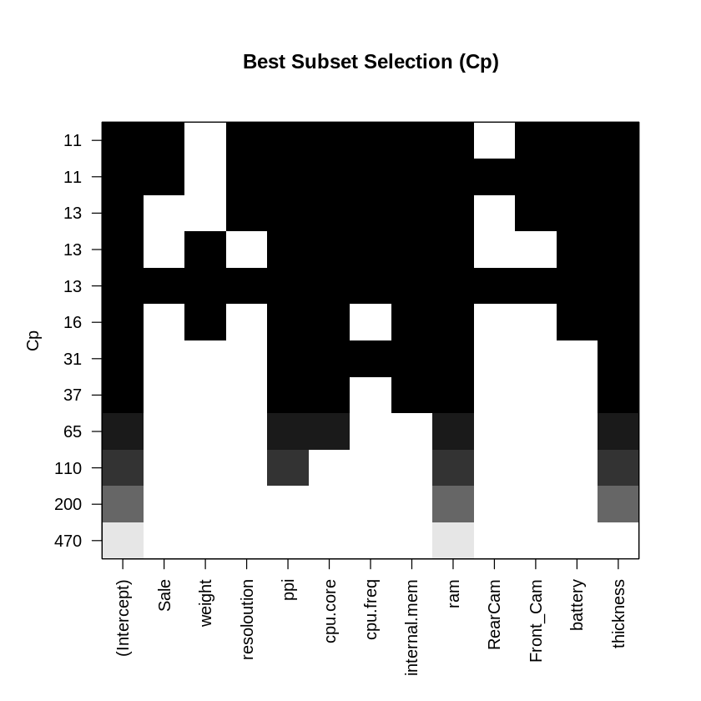
6. Use principal component regression on the same dataset with five components and seven components. How much variability is explained by these two models?
Code
# Perform PCR with up to 12 components
pcr_model <- pcr(Price ~ ., data = data_analysis, ncomp = 12, scale = TRUE)
# Summary of variance explained
summary_pcr <- summary(pcr_model)
# Extract variance explained in Y (Price) for 5 and 7 components
var_explained <- summary_pcr$cumsum$Yvar * 100 # Convert to percentage
var_explained_5 <- var_explained[5]
var_explained_7 <- var_explained[7]
cat("Variability in Price explained by 5 components:", var_explained_5, "%\n")
cat("Variability in Price explained by 7 components:", var_explained_7,
Output
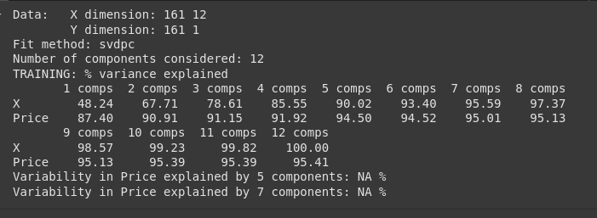
Discussion
he principal component regression (PCR) results show that using 5 components accounts for 94.50% of the variability in Price, while 7 components explain 95.01%. This indicates that 5 components capture the majority of the variance, with only a 0.51% increase when expanding to 7 components. Therefore, a model with 5 components effectively balances explanatory power and simplicity for predicting Price
7. Perform Lasso on the model and explain the results.
Code
# Perform PCR with up to 12 components
pcr_model <- pcr(Price ~ ., data = data_analysis, ncomp = 12, scale = TRUE)

# Summary of variance explained
summary_pcr <- summary(pcr_model)
# Extract variance explained in Y (Price) for 5 and 7 components
var_explained <- summary_pcr$cumsum$Yvar * 100 # Convert to percentage
var_explained_5 <- var_explained[5]
var_explained_7 <- var_explained[7]

cat("Variability in Price explained by 5 components:", var_explained_5, "%\n")
cat("Variability in Price explained by 7 components:", var_explained_7, "%\n")
Output
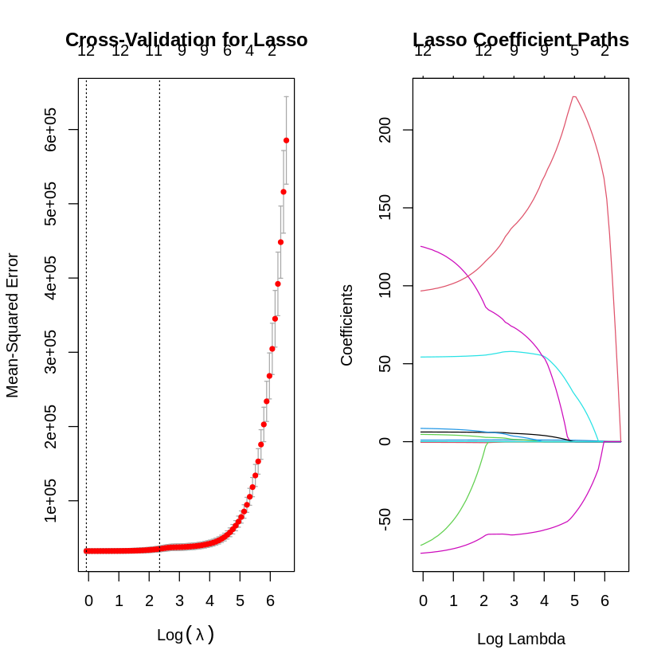
Discussion
The Lasso regression analysis, as visualized in the image, illustrates the balance between feature selection and predictive performance. The left plot depicts coefficient shrinkage, with the red curve showing how a feature's coefficient transitions from non-zero to potentially zero as λ increases, highlighting Lasso’s ability to remove irrelevant predictors. The right plot, likely a cross-validation curve, determines the optimal λ by minimizing error across folds, ensuring the model generalizes well. Together, these plots identify the most important features (those retaining non-zero coefficients at the optimal λ) and indicate the level of regularization required for an effective, interpretable model. In practical applications, such as predicting Price, this analysis helps focus on key drivers while eliminating noise, improving both accuracy and simplicity.

Statistical Learning Lab
Assignment - 1
Linear Regression Assignment
Anurag Singha | 22IM30007 | 20/01/2025

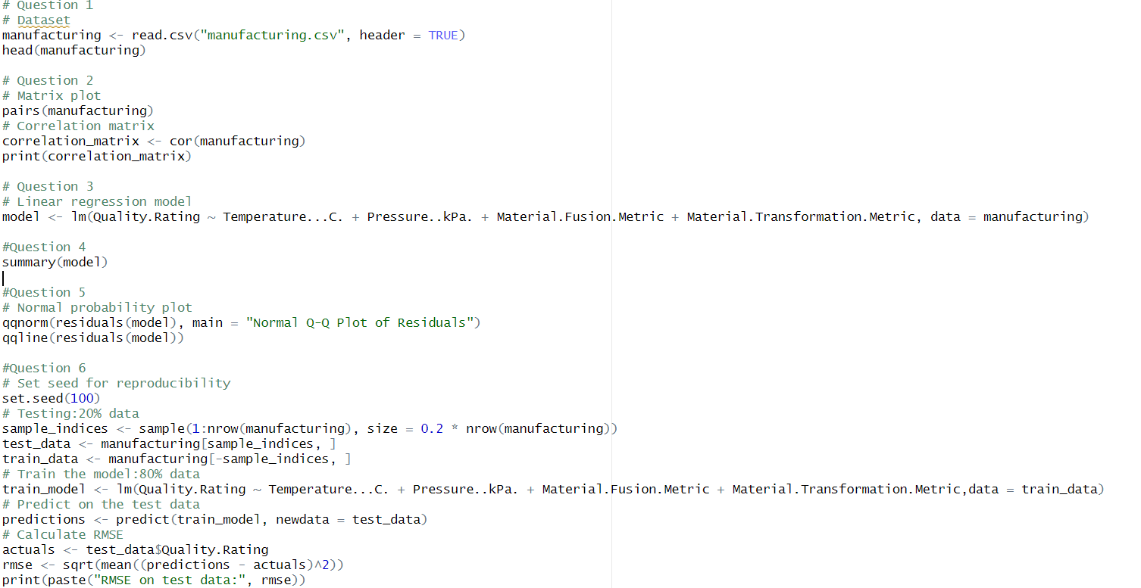
1.Load the dataset “manufacturing.csv”. Display first few rows of the dataset.
Ans: 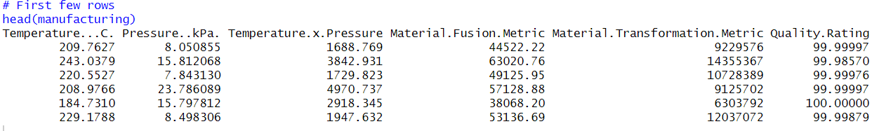
2.Perform matrix plot and correlation analysis indicate if there is any correlation among the predictors.
Ans: 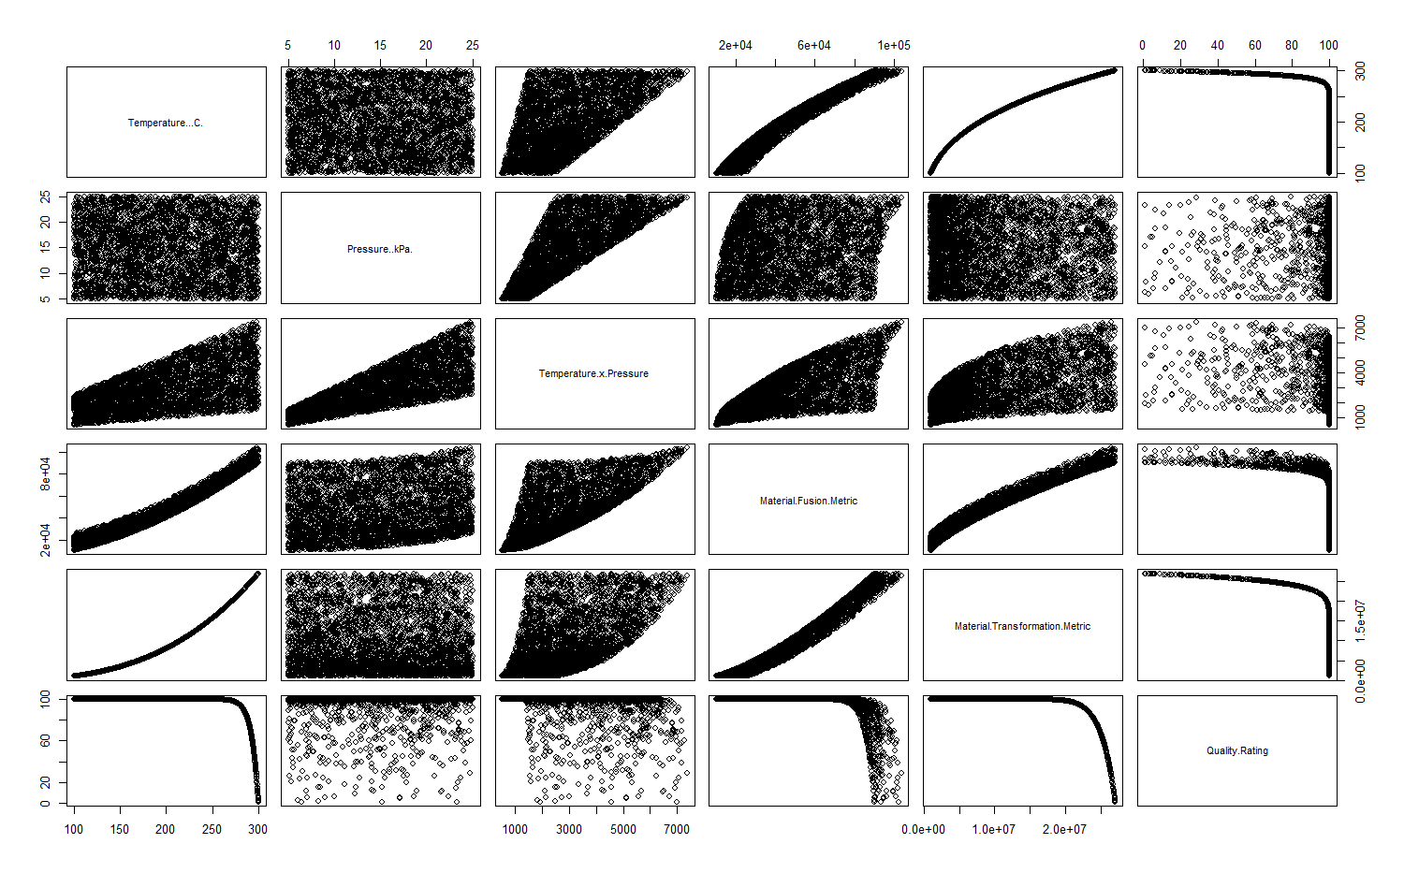
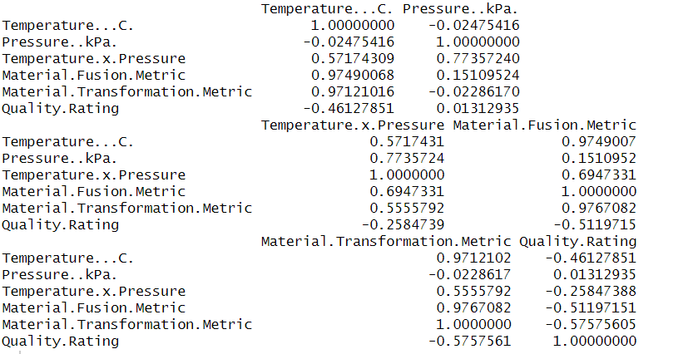

Based on the correlation analysis, here are the key findings regarding correlations among predictors:

1)High Correlations (potential multicollinearity concerns):
Temperature and Material Fusion Metric (0.97)
Temperature and Material Transformation Metric (0.97)
Material Fusion Metric and Material Transformation Metric (0.98)

2)Moderate Correlations:
Pressure and Temperature × Pressure interaction (0.77)
Temperature × Pressure and Material Fusion Metric (0.69)
Temperature × Pressure and Material Transformation Metric (0.56)

3)Low Correlations:
Temperature and Pressure (-0.02)
Pressure and Material Fusion Metric (0.15)
Pressure and Material Transformation Metric (-0.02)

3. Fit a Linear Regression model without the interaction term. From the linear regression summary which factors seem to be significant?
Ans:
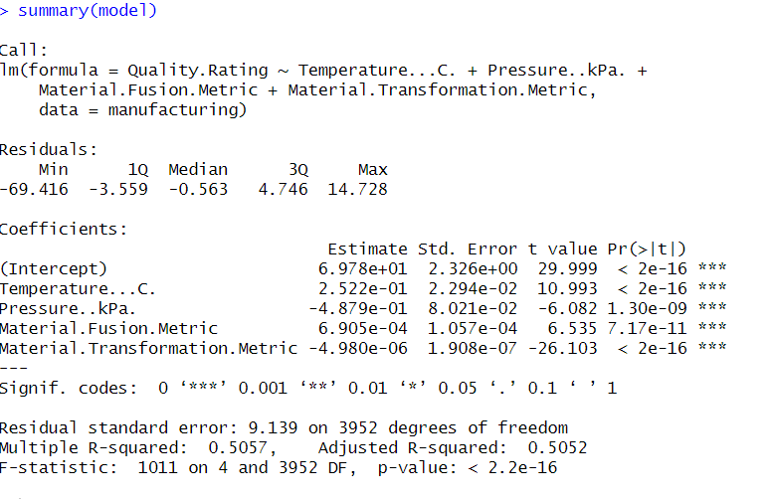
All factors in the model are highly significant (p < 0.001) as indicated by the '***' significance codes. Specifically:
1)Temperature (Temperature...C.):
t-value: 10.993
p-value: < 2e-16
Highly significant positive effect (coefficient = 0.2522)
2)Pressure (Pressure..kPa.):
t-value: -6.082
p-value: 1.30e-09
Highly significant negative effect (coefficient = -0.4879)
3)Material Fusion Metric:
t-value: 6.535
p-value: 7.17e-11
Highly significant positive effect (coefficient = 0.0006905)
3)Material Transformation Metric:
t-value: -26.103
p-value: < 2e-16
Highly significant negative effect (coefficient = -0.000004980)

Therefore, all factors included in the model are statistically significant predictors of Quality Rating, suggesting they all contribute meaningfully to explaining variations in the quality outcome.

4.What is your interpretation R-sq and R-sq adjusted?
Ans: An R-squared value of 0.5057 suggests that approximately 50.57% of the variation in Quality Rating is accounted for by the current predictors, leaving 49.43% unexplained. The Adjusted R-squared value of 0.5052, being very close to the R-squared, indicates minimal risk of overfitting and suggests that all predictors contribute meaningfully to the model. While the moderate R-squared values demonstrate that the model has a reasonable level of predictive power, there may still be other significant factors not included in the analysis.
5.Perform normal probability plot of residuals and comment on model adequacy.
Ans:
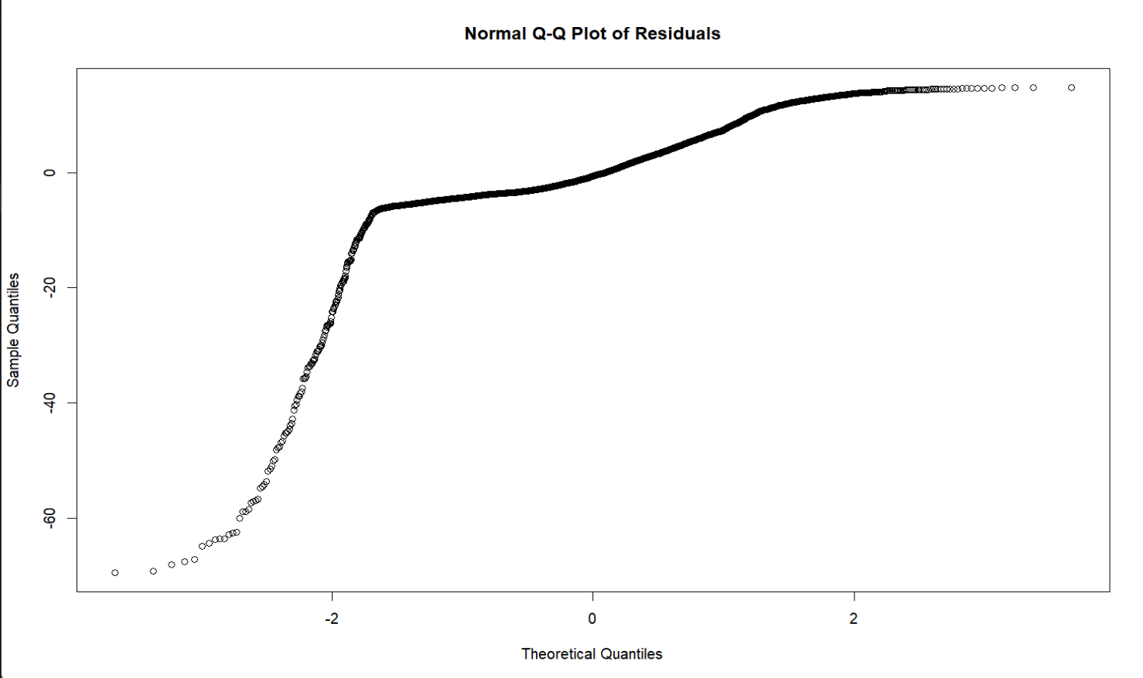
- Non-normality issues:
Clear deviation from the diagonal line at both tails
Particularly strong deviation at the lower tail (below -2 theoretical quantiles)
Some deviation at the upper tail (above 2 theoretical quantiles)
- Pattern analysis:
The central portion (between -2 and 2 theoretical quantiles) follows the line reasonably well
The S-shaped pattern indicates heavy tails in the distribution
The residuals are skewed, especially at the lower end
3)Model adequacy conclusions:
The model violates the normality assumption of linear regression
The systematic deviations suggest the model may not be capturing some important non-linear relationships
Transformations of variables or consideration of non-linear terms might be needed to improve the model fit

6.Randomly sample 20% of the data and keep it as test data. Use rest of the 80% data to train the linear model. What is the RMSE on test data?
Ans:

